

**MIDDLE EAST TECHNICAL UNIVERSITY**

**DEPARTMENT OF ELECTRICAL & ELECTRONICS ENGINEERING**

**EE 463- Static Power Conversion I - Hardware Project**

***AAAAAAAAAAAAAA***

**DC Motor Drive**

**Simulation Report**

*Prepared for Assoc. Prof. Ozan KEYSAN*

**Birkan Genç- 2443059**

**Ali Taşkıran -**

**Erdem Canaz -**

**Table of Contents**

Introduction & Specification 3

Topology Selection 3

Three Phase Thyristor Rectifiers 3

Advantages 3

Disadvantages 3

Three Phase Diode Rectifier & Buck Converters 3

Advantages 3

Disadvantages 3

Why Diode Rectifier & Buck Converters 3

Analytical Calculation 4

Buck Converter Design 4

Rectifier Design 4

555 Timer Calculations 4

Simulation 6

***3-Phase Diode Rectifier:*** 6

***A555 Controller*** 8

***Buck Converter*** 9

MOSFET 9

Component Selection 10

***Rectifier Diode*** 10

***Timer*** 11

***IGBT*** 11

***Freewheeling Diode*** 12

***Capacitor & Resistor*** 12

***Fuse*** 12

***Gate Driver*** 13

Conclusion 13

# **Introduction & Specification**

aaaaaaa

# **Topology Selection**

## Three Phase Thyristor Rectifiers

#### Advantages

* It has less ripple voltage compared to single phase thyristor rectifiers.
* Since the ripple voltage is smaller, the average DC voltage is higher than the single-phase thyristor rectifier.
* It needs a smaller capacitor since the ripple voltage is less.
* Can reach 1.35 times of input line-line voltage.

#### Disadvantages

* More complicated structure.
* The gate control is harder than the single-phase thyristor rectifier.
* It needs more circuit equipment; therefore cost is higher.
* The power factor is still small due to the THD of the input current.

## Three Phase Diode Rectifier & Buck Converters

#### Advantages

* Controlling is easy compared to thyristor rectifiers.
* Using a bridge rectifier, it is more compact.
* Can reach 1.35 times of input line-line voltage.

#### Disadvantages

* In order to minimize inrush current, an inductor should be added to the circuit.
* Its cost is high since the buck converter is the switching equipment. (IGBT, MOSFET etc.)

## Why Diode Rectifier & Buck Converters

We choose 3-phase diode rectifier and buck converter topology in order to drive the DC machine because of these reasons:

* Constructing a diode rectifier is easier than other topologies.
* Constructing a buck converter is cheaper than other topologies since the DC machine already provides the necessary inductor, capacitor, and resistors.
* By using a 555 timer, we can control the buck converter’s switch’s gate. This is more complicated in thyristor rectifiers.

# **Analytical Calculation**

## Buck Converter Design

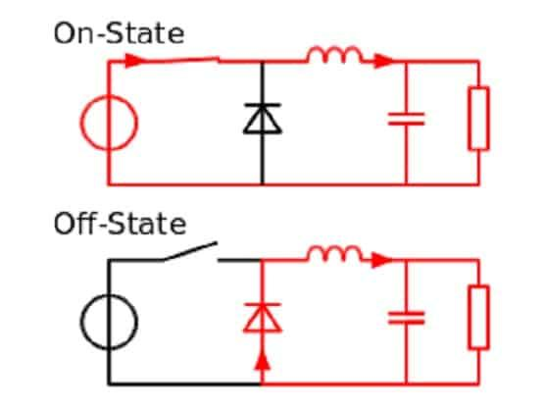

## Rectifier Design

## 555 Timer Calculations

Basic 555 timer structure can be found in below:

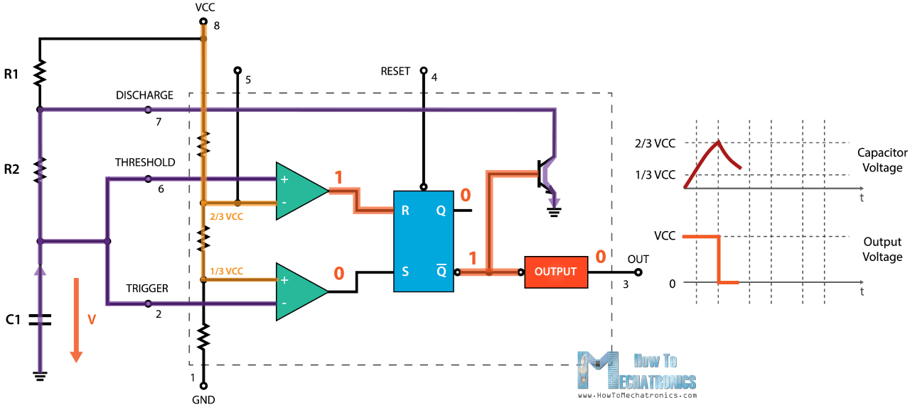

*Example schematic of 555 timer*

Formulas,

$$T_{on}=0.693*(R_{1}+R_{2})*C_{1}$$

$$T_{of}=0.693*R_{2}*C_{1}$$

$$T_{total}=0.693*{(R}_{1}+2R_{2})*C_{1}$$

$$f=1/(0.693*{(R}_{1}+2R_{2})*C_{1})$$

$$PWM\left(\%\right)=\frac{T_{on}}{T_{total}}=\frac{(R_{1}+R_{2})}{{(R}_{1}+2R_{2})}*100$$

In order to create adjustable PWM, we add this configuration to the diodes and POTs via the charging and discharging paths.

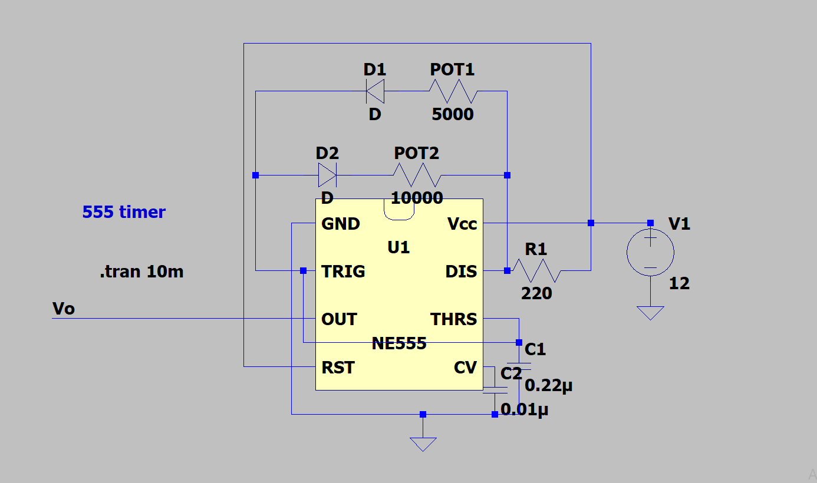

*555 Timer Circuit unit modelled in LTspice*

Calculations,

$$T_{on}=0.693*{(R}_{POT1}+R_{1})*C_{1}$$

$$T_{of}=0.693*{(R}_{POT2}+R_{1})*C_{1}$$

$$T_{total}=0.693*{(R}_{POT1}+R_{POT2}+{2R}_{1})*C_{1}$$

$$f=1/(0.693*{(R}_{POT1}+R_{POT2}+2R_{1})*C_{1})$$

$$PWM\left(\%\right)=\frac{T_{on}}{T_{total}}=\frac{R_{POT1}+R_{1}}{R_{POT1}+R_{POT2}+2R_{1}}*100$$

We have used 5kΩ and 10kΩ resistance respectively for POT1 and POT2. In real, POT1 is changing between 1.6Ω and 4.8k Ω and POT2 is changing between 2.8Ω and 9.6kΩ. Then,

PWM maximum,

$$T_{on}=0.693*\left(4.8kΩ+220Ω\right)*0.22*{10}^{-6}=0.795ms$$

$$T_{of}=0.693*\left(2.8+220Ω\right)*0.22*{10}^{-6}=0.034ms$$

$$f=1.19kHz$$

$PWM\left(\%\right)=$ 98%

PWM minimum,

$$T_{on}=0.693*\left(1.6Ω+220Ω\right)*0.22*{10}^{-6}=0.0337ms$$

$$T_{of}=0.693*\left(4.8k+220Ω\right)*0.22*{10}^{-6}=1.558ms$$

$$f=628Hz$$

$PWM\left(\%\right)=$ 2.1%

Although we could reach these PWM values, we must stay away from the boundary points of PWM. This is because at the near 0% and 100% PWM values, the switch (IGBT) cannot be operated properly since it has a switching time interval of ON and OFF times, PWM is not enough to compensate for it. Therefore, we changed R1 with 1kΩ and we have adjusted PWM between 17% and 85%. By the same steps,

PWM maximum,

$$T_{on}=0.884ms$$

$$T_{on}=0.152ms$$

$$f=965Hz$$

$PWM\left(\%\right)=$ 85%

PWM minimum,

$$T_{on}=0.152ms$$

$$T_{on}=0.884ms$$

$$f=965Hz$$

$PWM\left(\%\right)=$ 17%

As seen from obtained results, the operating frequency is around 1kHz, so we decide to use IGBT as a switch. The performance of IGBT is greater than MOSFETs and other switches at low frequencies. Also, the current rating of IGBTs can reach up to 1kA.

# **Simulation**

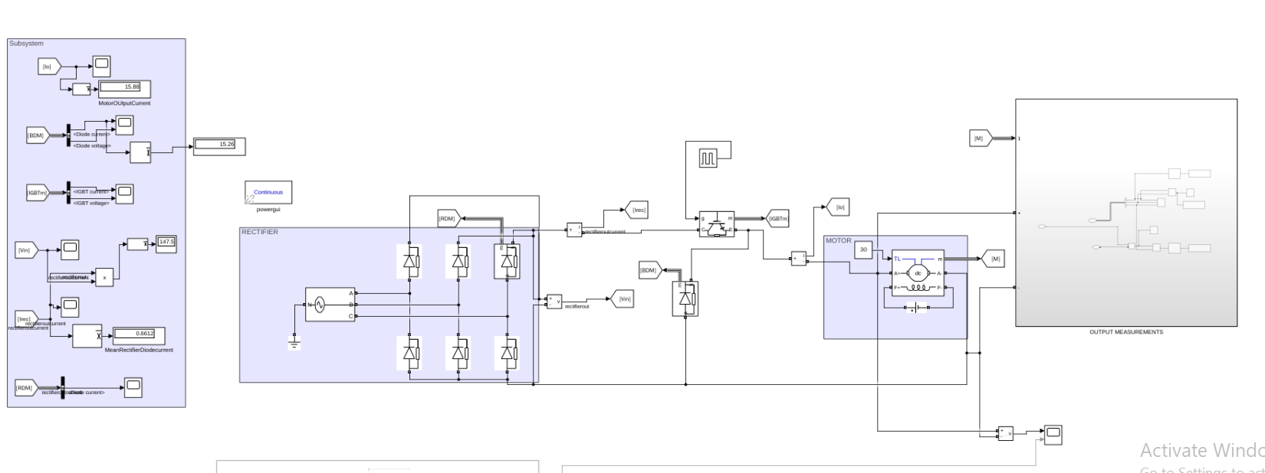

*Screenshot of overall circuit design of DC Motor Drive designed in Simulink*

## ***3-Phase Diode Rectifier:***

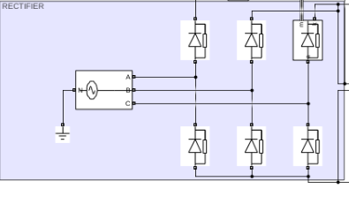

*Zoom-in version for rectifier side of overall model*

*Plots of current and voltage of rectifier output vs. time*

Rectifier diode current and voltage waveforms,

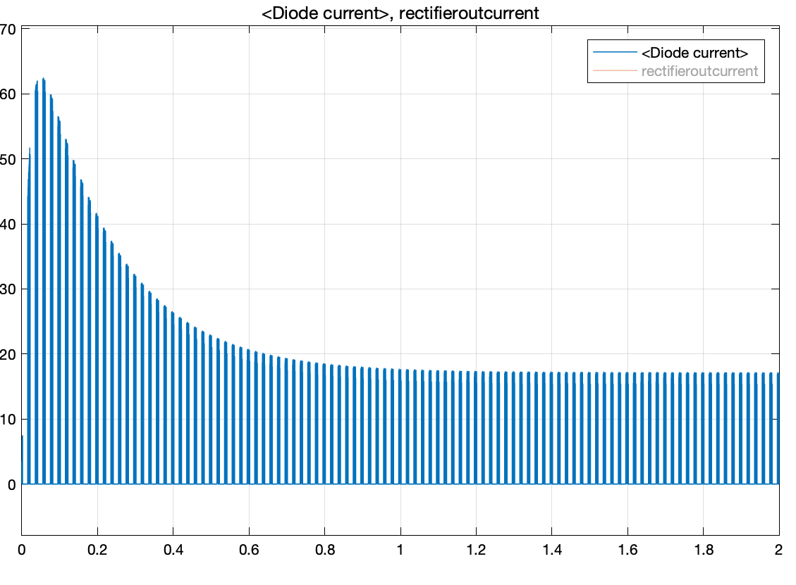

*Plot of rectifier diode current vs. time*

The graph which can be seen above shows the diode’s starting current if we set the initial duty cycle as 0.2. However, since we don’t know the line impedance, we didn’t add any value to our simulation. Therefore, we expect that less inrush current will be measured in laboratory conditions. Another factor of high starting current is the stationary motor. When the motor is stationary, armature voltage is equal to zero. Then, when we supply voltage to the DC machine, the high current is passing through armatures. This becomes very problematic since it can damage the circuit. Therefore, we still try to stabilize the armature current for soft-starting.

## ***A555 Controller***

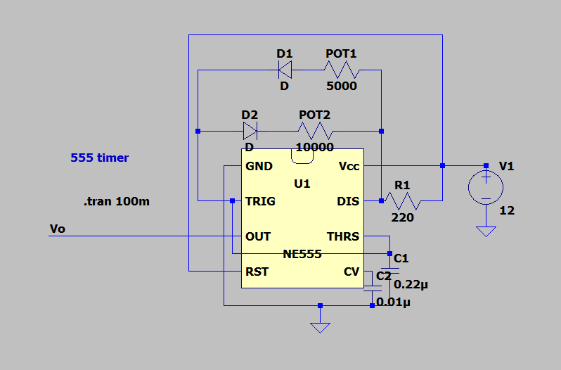

*Schematic of NE555 timer in LTspice*

Maximum duty cycle case:

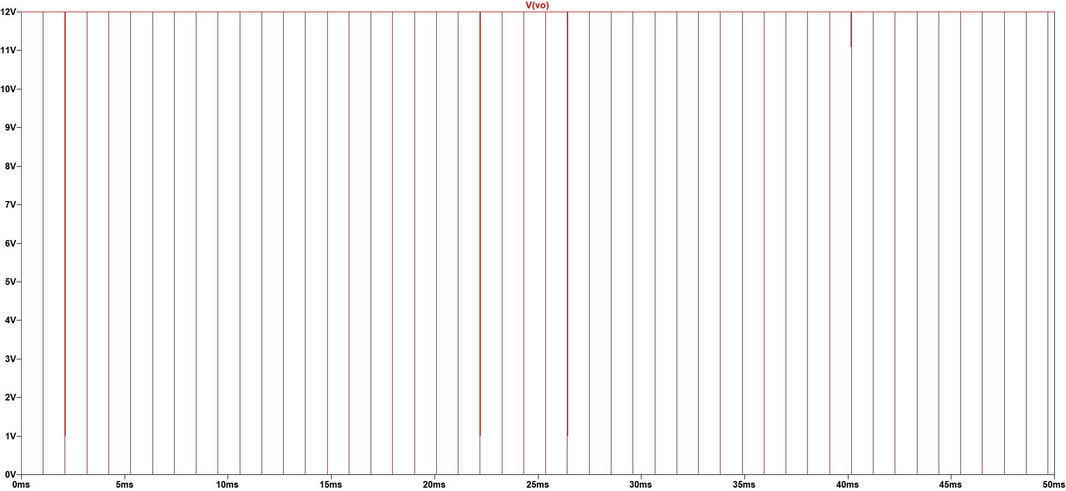

*Plot of output voltage of NE555 vs. time for maximum duty cycle*

Minimum duty cycle case,

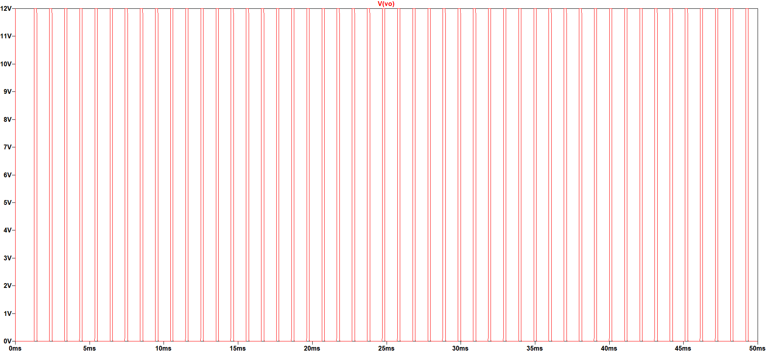

*Plot of output voltage of NE555 vs. time for minimum duty cycle*

According to our research, we see that the most convenient way to control the buck converter is using the ASTABLE 555 Timer circuit. An Astable timer can be controlled just by using POTs.

The most crucial advantage of this timer is changing duty cycle easily. However, the frequency changes according to the resistor values that we change. Therefore, it may be a disadvantage. On the other hand, we are using an IGBT for buck converter and it is proper for the 1-5kHz interval. Therefore, we calculated the resistance of the timer to work between these frequency intervals. Beside all of these, 555 Timer topology is a familiar concept for us from the last year’s EE312 course. We are considering that challenging by a circuit model that we had studied can be more time-saving and root-cause analysis can be done more effectively.

In the timer circuit above, R1 & R2 values determine the frequency and the duty cycle of the circuit. We are planning to change both R1 & R2 during our project. The related formulations and description can be seen in the “Analytical Calculation” part.

## ***Buck Converter***

### MOSFET

…

# **Component Selection**

*Table 1. All chosen components list*

|  |  |  |  |  |
| --- | --- | --- | --- | --- |
| **Component** | **Manufacturer Number** | **Quantity** | **Price(₺)** | **Total Price(₺)** |
| **Three phase bridge diode** | SKBPC5016 | 1 | 38.5 | 38.5 |
| **Timer** | NE555P DNSX19 | 1 | 2.6 | 2.6 |
| **IGBT** | IXGH24N60C4D1 | 1 | 36.45 | 36.45 |
| **Diode** | DSEI30-06A | 1 | 40.03 | 40.03 |
| **Transistor** | BC308B | 1 | 1.33 | 1.33 |
| **Gate Driver** | HCPL-3120 | 1 | 22.67 | 22.67 |
| **Fuses(30A 6*30mm ceramic fuse )** | - | 5 | 2.66 | 13.33 |
| **Capacitor(3.3uF 400V ceramic capacitor)** | - | 1 | 0.888 | 0.888 |
| **Capacitor(220nF 630Vdc)** | - | 1 | 1.13 | 1.13 |
| **Capacitor(10nF 50V ceramic capacitor)** | - | 1 | 0.752 | 0 |

## ***Rectifier Diode***

**SKBPC5016 50A 1600V Three phase bridge diode**

(More information can be found attached datasheet in our repository.)

*Table 2. Critical parameter values of selected rectifier diode*

|  |  |
| --- | --- |
| **PEAK REPETITIVE REVERSE VOLTAGE** | 1600V |
| **AVERAGE RECTIFIED FORWARD CURRENT** | 50A |
| **PEAK REVERSE CURRENT** | 10uA |
| **NON-REPETITIVE PEAK SURGE CURRENT** | 500A |
| **FORWARD VOLTAGE(IFM=17A)** | 1.2V |

According to our simulations and calculations, we see that we need a diode which can carry at least 30A. Since three-phase bridge diodes are cheaper than 6 diodes and they have a smaller size, as also the implementation is much easier. Thus, we choose three-phase bridge rectifier diode. It can carry 50A for 1600V.

## ***Timer***

**NE555P DNSX19**

(More information can be found attached datasheet in our repository.)

Since we generate a PWM by using only capacitors and resistors, we choose the NE555 Timer. This timer can generate PWM from microsecond to hour intervals. We are aiming to generate 1-5kHz square waves in our circuit.

## ***IGBT***

**IXGH24N60C4D1 N Channel IGBT, High Gain 600V**

(More information can be found [here](https://github.com/kkaya674/EE463-TermProject/blob/main/Datasheets/IGBTs/selectedigbt.pdf) in our repository.)

*Table 3. Critical parameter values of selected IGBT*

|  |  |
| --- | --- |
| **COLLECTOR-EMITTER VOLTAGE** | *600V* |
| **GATE-EMITTER VOLTAGE** | *+/- 20V* |
| **COLLECTOR CURRENT** | *56 A @ 25°* |
| **POWER DISSAPATION** | *190 W* |
| **OPERATING TEMPERATURE** | *-55°C / +150°C* |

We calculated and measured that we will use at most 25A in our circuit at the steady state. Since the range of MOSFETs are not enough, we will use IGBT in our circuits. In our research, we couldn’t find an IGBT that has higher current capability than **IXGH24N60C4D1.** Therefore, we decided to use this IGBT which also exists in the laboratory.

## ***Freewheeling Diode***

**DSEI30-06A 37A 600V 35ns Ultrafast Diode**

(More information can be found in [here](https://github.com/kkaya674/EE463-TermProject/blob/main/Datasheets/Diodes/DSEI30-6A.pdf) in our repository.)

*Table 4. Critical parameter values of selected diode at buck converter side*

|  |  |
| --- | --- |
| **RATED REPETITIVE REVERSE VOLTAGE** | 600V |
| **AVERAGE RECTIFIED FORWARD CURRENT** | 37A |
| **MAXIMUM REVERSE CURRENT** | 50uA |
| **FORWARD VOLTAGE** | 1.6V |
| **REVERSE RECOVERY TIME** | 50ns |

For low duty cycles, the current through the buck converter’s diode increases. Therefore, we have chosen the diode with the current rate accordingly. Also, since its recovery time is small, we eliminate the switching losses.

## ***Capacitor & Resistor***

We bought different capacitors and resistors for different purposes. Since we will use these capacitors in our controller, we don’t consider currently for their voltage and power ratings at uppermost level since there is a still on-going process for our controller implementation. However, as we mentioned in previous parts, we bought some capacitors to connect the input terminals of the DC machine if it is needed. These capacitors are suitable for high voltage applications. Their voltage ratings are 400V.

## ***Fuse***

**30A 6x30mm Ceramic Fuses**

According to our calculations and circuit element current rates, current value should not exceed some limits. To prevent damage in the circuit, we bought ceramic fuses.

## 

## ***Gate Driver***

**HCPL-3120 2.5 Amp Output Current IGBT Gate Drive Optocoupler**

To prevent high voltage drop on gate-emitter voltage of IGBT, we have added a gate driver to our design. The [HCPL3120](https://github.com/kkaya674/EE463-TermProject/blob/main/Datasheets/GateDriver/hcpl3120-datasheet.pdf) has an insulation voltage of VIORM=630 Vpeak and it provides 2.5A to the gate of IGBT. These values are very high among other gate drivers and suitable for our design.

*Table 5. Critical parameter values of gate driver*

|  |  |
| --- | --- |
| **MINIMUM PEAK OUTPUT CURRENT** | 2A |
| **INSULATION VOLTAGE** | 630V |
| **TEMPERATURE RANGE** | 40-100*°C* |
| **MAXIMUM SWITCHING SPEED** | 500ns |

# **Conclusion**

The goal of this project is to demonstrate the lecture's outcomes on a broader level. We devised a circuit that rectifies three-phase AC voltage and lowers it to a DC Voltage   Then we created the simulation of duty cycle cases.   The concept here is that simulation is a method for selecting components to create a stable and effective solution So, after that, we picked the components for the simulations based on our analytical calculations and simulation results. Finally, we started our test and recordings our observations and measurements in an experimental environment at our lab while we also began using the design application EasyEDA to develop the schematics of our components and subsystems for this stage of the project.

For conclusion, we can say that we are about to complete our controller circuit. Also, we did a lot of simulations so far for the rest of the circuit. We can only say this is not a last day project because we are continuously returning to complete or overwrite to develop our solution or reduce the mistakes on our solution.